# EXPERIMENT NUMBER –Practical 1.1

STUDENT’S NAME – Shinde Smita Shahaji

STUDENT’S UID – 20BCS4643

CLASS AND GROUP –CSE-IOT(GROUP B)

SEMESTER – 2ND

TOPIC OF EXPERIMENT –

# Program to find average marks of five subjects of a student in a class.

AIM OF THE EXPERIMENT ­-

# Learn the basics of C++ programming.

FLOWCHART/ ALGORITHM -

START

# Step 1→ Creating a header file for input output stream and define the context.

# Step 2 → Declaration of function that returns integer value.

# Step 3→ Declaration of variables in integer and float datatype.

# Step 4 → Print the message and accept the input from the user.

# Step 5→ Loop is used to enter the marks of the subject

# Step 6→ Calculate total marks by using the formula: total += marks

# Step 7→ Calculate average of marks by using the formula : Average = total marks / no. of subjects

# Step 8 → End the program by returning an integer valve.

# Stop

PROGRAM CODE

#include <iostream>

using namespace std;

int main () {

int subject, i;

float mark, total, avrg;

cout << " \nEnter Number of subject";

cin >> subject;

cout << " \nEnter Number mark";

for (i = 0; i < subject; i++)

{

cin >> mark;

total += mark;

}

avrg = total / subject;

cout << "\n Total = Sum of Number marks \n " << total;

cout << "\n Average marks = Total / Sum of Number marks\n " << avrg;

return 0;

}

ERRORS ENCOUNTERED DURING PROGRAM’S EXECUTION

(Kindly note down the compile time errors encountered)

1. Semicolons was missing.
2. Parenthesis(brackets) was missing.
3. Double quotes were missing in string.
4. Missing space between “using namespace std”

PROGRAMS’ EXPLANATION (in brief)

# In the given program we are calculating the average of 5 subjects by taking Loop is used to enter the marks of the subject .Now dividing sum by total and storing this average value to avg and displaying the result.

OUTPUT

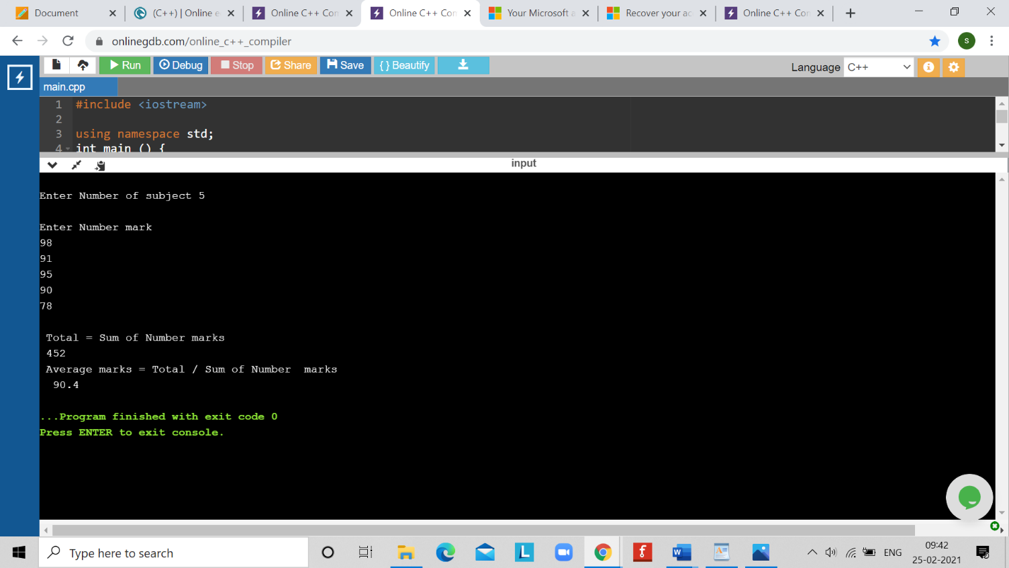

LEARNING OUTCOMES

|  |
| --- |
| * Identify situations where computational methods would be useful. |
| * Approach the programming tasks using techniques learnt and write pseudo-code. |
| * Choose the right data representation formats based on the requirements of the problem. |
| * Use the comparisons and limitations of the various programming constructs and choose the right one for the task. |

EVALUATION COLUMN (To be filled by concerned faculty only)

|  |  |  |  |
| --- | --- | --- | --- |
| **Sr. No.** | **Parameters** | **Maximum**  **Marks** | **Marks**  **Obtained** |
| 1. | Worksheet Completion including writing learning objective/ Outcome | 10 |  |
| 2. | Post Lab Quiz Result | 5 |  |
| 3. | Student engagement in Simulation/ Performance/ Pre Lab Questions | 5 |  |
| 4. | Total Marks | 20 |  |